

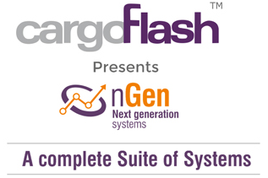

Handbook – Agent Portal

142, Udyog Vihar, Phase-IV, Haryana. 122001. India. **Tel:** +91-124-7125036, 7125081 Fax**:** +91-124-7125044 **Email**: [info@cargoflash.com](mailto:info@cargoflash.com) **Web**: <http://www.cargoflash.com/>

Table of Contents

[**Introduction** 4](#_Toc502998375)

[This document covers the Cargo processes done by the agents/forwarders of Garuda Indonesia Cargo, the module enables the users to enquire about the available flight schedules, applicable rates, make a new shipment booking, execute a shipment, take Airway Bill and Label printouts and track and trace a shipment. 4](#_Toc502998376)

[**1.** **Stock** 7](#_Toc502998377)

[This module provides information to the user with the Air waybill information 7](#_Toc502998378)

[To access the stock screen in the system, please go to the ‘Stock’ module from the top menu this will list down two options, AWB Stock Report and AWB Stock History. 7](#_Toc502998379)

[1.1. **AWB Stock Report** 7](#_Toc502998380)

[This sub-module gives details about the AWBs that have been issued to the agent. From the opened stock module 7](#_Toc502998381)

[1.2. **AWB Stock History** 10](#_Toc502998382)

[This sub-module gives historical information about the movement of AWBs that have been issued to the agent. From the opened stock module 11](#_Toc502998383)

[**2.** **Reservation** 13](#_Toc502998384)

[This module allows users to create a new booking, apply allotments, apply spot rates, execute a shipment, print AWB, print labels and attach scanned documents to the e-pouch. 13](#_Toc502998385)

[2.1. The AWB Grid – 15](#_Toc502998386)

[2.2. New Booking – 18](#_Toc502998387)

[**2.2.1.** Reservation – This is the first step for reservation, In this section the primary information for the shipment booking is provided this includes destination, product, weight details, etc. each of this fields with steps have provided below – 19](#_Toc502998388)

[**2.2.2.** Shipper/Consignee information – This section is used to enter the shipper/consignee information, during booking this is optional and user may wish to skip this, however, at the time of execution filling the shipper consignee information is mandatory – 22](#_Toc502998389)

[User can use the existing system database for entering the shipper and consignee information, to do this from the account number drop down select the account number or the shipper name; all the fields as saved in the database will be updated. 22](#_Toc502998390)

[In case a shipper or consignee does not exist in the system database then user can manually enter the details manually, in case user wants to save such new data entry in the system database then he/she can select the checkbox against the ‘Account Number’ dropbox. This is shown with a red arrow in the figure 15. 22](#_Toc502998391)

[**2.2.3.** Itinerary – This is the section where user selects the route and flights on which shipment needs to be sent. The steps to select and/or create a route is explained broadly in the figure 16 below and thereafter the steps are explained one by one in detail. 22](#_Toc502998392)

[iv. Now the origin airport is auto filled with the destination airport of the first selected flight 25](#_Toc502998393)

[v. In the destination airport enter the flight destination and click on ‘search’ 25](#_Toc502998394)

[vi. Select the flight. 25](#_Toc502998395)

[vii. Repeat steps ‘iv’ to ‘vi’ till final destination is updated and route is completed 25](#_Toc502998396)

[viii. System will not allow incomplete routed shipment to be saved. 25](#_Toc502998397)

[ix. In case user wants to terminate shipment at a particular transit point and not book till the final destination, then user needs to select the checkbox named ‘routing complete’, this will allow the user to save an incomplete routed shipment. 25](#_Toc502998398)

[2.3. Update Booking – 25](#_Toc502998399)

[2.4. Execute Booking – 28](#_Toc502998400)

[2.5. E-Dox or E-Pouch – 30](#_Toc502998401)

[**3.** **HAWB Capture** 31](#_Toc502998402)

[This is the Consolidation List or FHL CIMP message sent by the agents giving details on the House Waybill under a particular Air Waybill for a shipments that are booked on a particular flight on a date. This gives the system the details of House Airway Bill (HAWB) which are brought by the agents and do an acceptance of shipments under HAWB. In case the FHL message has not been received then user also has the option of manually adding the HAWBs here. 31](#_Toc502998403)

[To access the ‘HAWB Capture ’ screen in the system, please go to the ‘Reservation’ module for the top menu and from the available 31](#_Toc502998404)

[3.1. Adding new HAWB – 31](#_Toc502998405)

[On the above screen (figure 24) the details of the Maser Air waybill is listed including Lot number (in case shipments are received in part) & AWB number, number of pieces in the total shipment, number of HAWB under this AWB, etc. In order to add HAWB user must click on the ‘Add’ button (figure 25), this open the below screen as shown in figure 25 33](#_Toc502998406)

[**4.** **Rate** 35](#_Toc502998407)

[The rate module of the system allows the agents to search for the published rates, promo rate of its own RSP rate. 35](#_Toc502998408)

[To access the rate screen in the system, please go to the ‘Rate’ module from the top menu this will list down two options, ‘Spot Rate Request’ and ‘Search Rate’. 35](#_Toc502998409)

[**4.1 Applying a Spot Rate** 35](#_Toc502998410)

[4.2 Search Rate 37](#_Toc502998411)

[Using the ‘search rate’ sub-modules’ agents can check the Airline Published rates, promo rates if any and even their own agent specific rates. To access the search rate sub-module, from the ‘Rate’ top menu sub-options click on ‘Search Rate’, this will open the following screen: 37](#_Toc502998412)

[The steps to search rates have been given below: 39](#_Toc502998413)

[**5.** **Schedule** 40](#_Toc502998414)

**GA – Agent Cargo Portal (ACaP)**

# **Introduction**

# This document covers the Cargo processes done by the agents/forwarders of Garuda Indonesia Cargo, the module enables the users to enquire about the available flight schedules, applicable rates, make a new shipment booking, execute a shipment, take Airway Bill and Label printouts and track and trace a shipment.

The agent portal functionalities are covered under four modules in the system

For accessing the export module in the cargo system please use the provided user ID and login details at the system url **https://icms.garuda-indonesia.com/account/garudalogin.cshtml** and follow the steps as shown below –

Figure 1: System Login Window

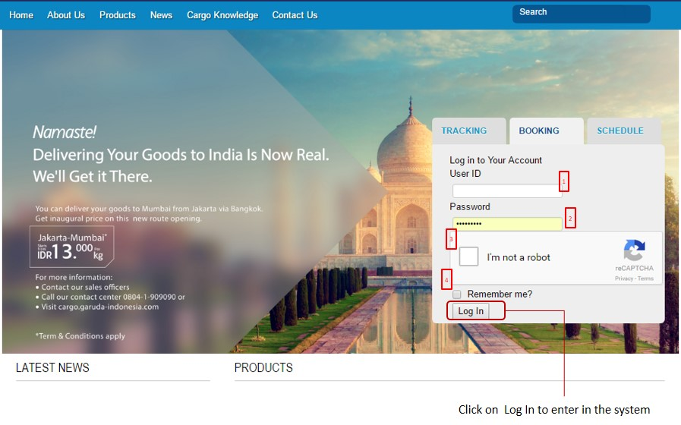

1. Please enter the provided user ID
2. Enter the provided system password correctly, please note that entering a wrong password three times will lock the user and thereafter in order to activate it, user needs to contact the system admin over email
3. Please check the ‘captcha’ for security purpose and follow the instruction for validating as a genuine person
4. The remember me check box can be used for system to remember the user ID and password on a particular machine (for security purpose do not use this function on a public terminal)
5. Click on Log In to enter the system, this will open the below system home page.

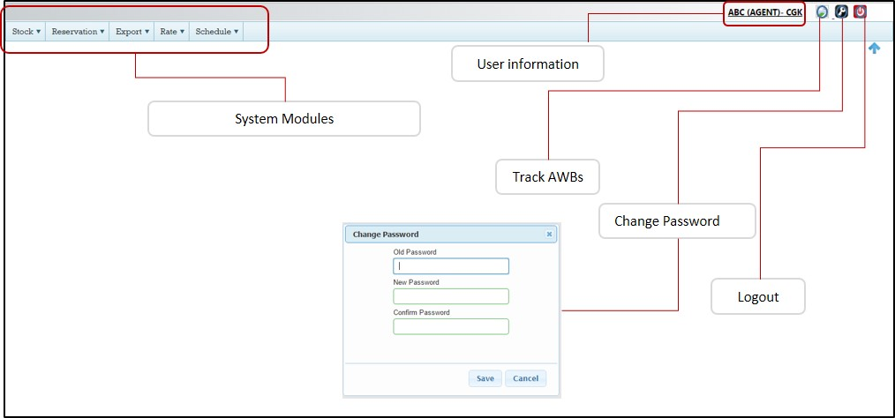

Figure 2: Home Page

The agent portal consists of the following modules, Stock, Reservation, Export, Rate and Schedule; each one of these have been discussed in detail in the following sections.

# **Stock**

# This module provides information to the user with the Air waybill information

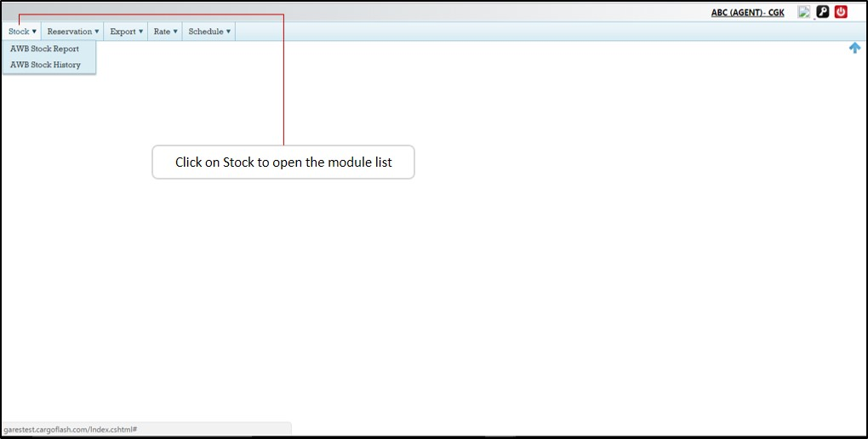

Figure 3: Module - Stock Management

To access the stock screen in the system, please go to the ‘Stock’ module from the top menu this will list down two options, AWB Stock Report and AWB Stock History.

# **AWB Stock Report**

This sub-module gives details about the AWBs that have been issued to the agent. From the opened stock module list click on ‘AWB Stock Report’ (figure 4), this will open the Stock Report screen which is further shown under figure 5

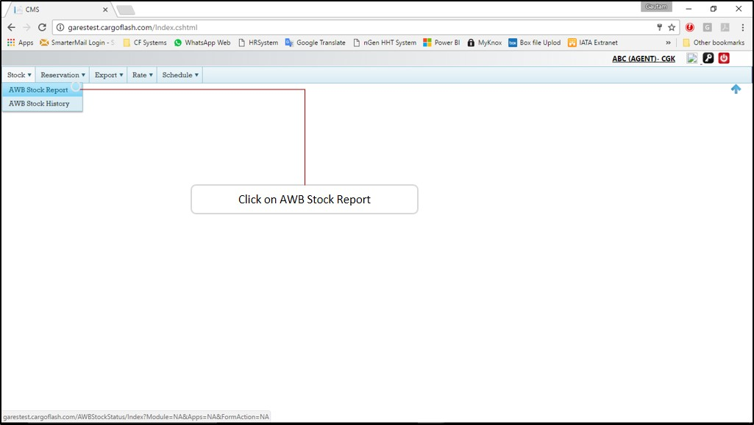

Figure 4: Accessing AWB Stock Report

Upon clicking this, it will open the stock report page (figure 5), for the agent login all the search options are prefilled and un-editable, user once clicks the search button will further expand the page with the following options –

* 1. The system opens a branch view of with giving information on how the AWB stocks moved, i.e. from the Airline to Branch/GSA and from there to the agent. User can click at each level to expand it and few details
  2. The stock details are listed as below –
     1. Total stock issued – This lists the total AWBs issued to the agent till date
     2. Stock unused – The number of AWBs lying unused with the agent as of now
     3. Stock issued to agent - This is the number of AWBs issued in the last batch
     4. Stock booked – This lists the number of AWBs currently booked
     5. Void – This lists the number of AWBs that have been made as void
     6. Black Listed – The AWBs that have been blacklisted by the Airline from the stock of agent are listed here
  3. Clicking on any of the values (number) will download a detailed report about those AWBs in an Excel format.

These steps have been also depicted in the system screenshot (figure 5) in the following page –

# **AWB Stock History**

Figure 5: Stock report view

This sub-module gives historical information about the movement of AWBs that have been issued to the agent. From the opened stock module list click on ‘AWB Stock History’ (figure 6), this will open the Stock History screen which is further shown under figure 6

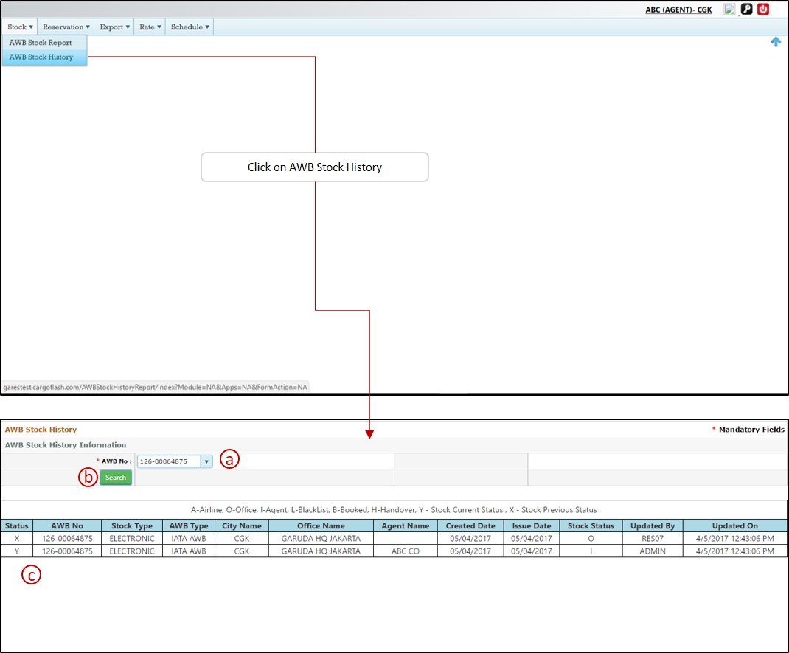

Figure 6; Stock History

1. This is the AWB dropdown list, and only the AWBs that have been issued to the agent are listed here, user can select the desired AWB and
2. Click search for listing the historical details of the AWB
3. This is where the historical details of the AWB is listed, ‘Y’ denotes the AWB current status and ‘X’ the previous status.

# **Reservation**

# This module allows users to create a new booking, apply allotments, apply spot rates, execute a shipment, print AWB, print labels and attach scanned documents to the e-pouch.

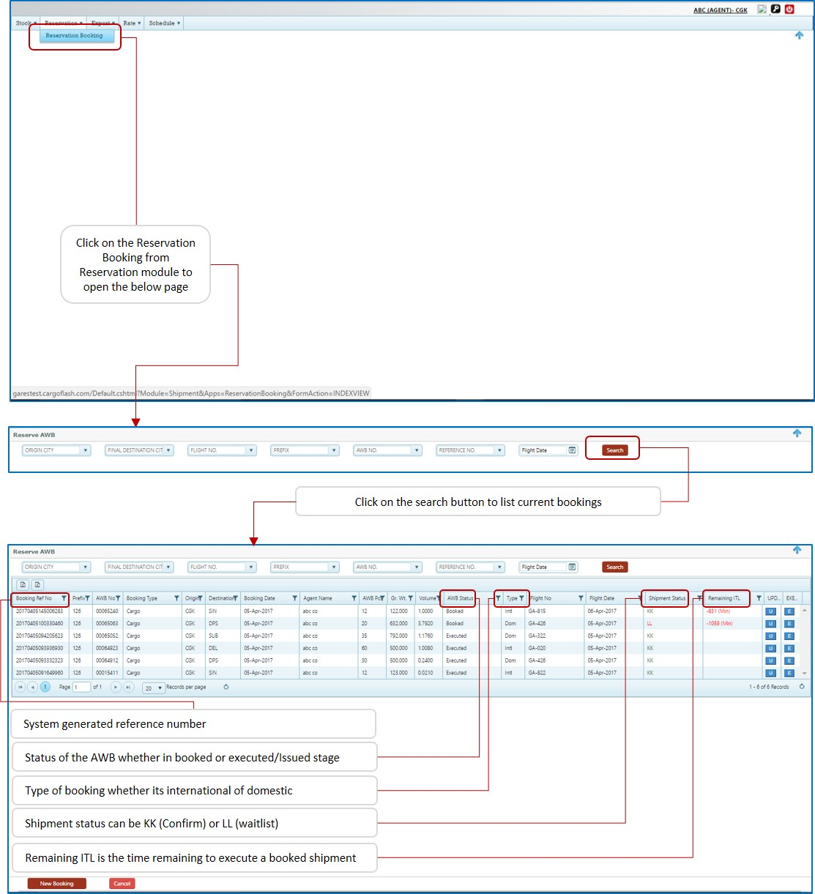In order to go to the reservation module, from the top menu click on ‘Reservation’ and from the opened sub-menu click on ‘Reservation Booking’, this will open the reservation grid as below (figure 7) -

Figure 7: Reservations

The reservation grid first opens the page with option to create a new booking by clicking on the ‘New Booking’ button on the lower left corner of the screen. The new booking process will be explained later in the document.

The other option that is displayed upon clicking on ‘Booking reservation’ submodule if the search filters; user can select from the available search filter options, that are –

1. Origin City
2. Final Destination
3. Flight number
4. Airline AWB prefix
5. Air Waybill number
6. Reference number
7. Flight number

All the above filter criteria are optional and can be used as a single filter or with any combination from the above, after selecting the required search filter user can click on search to list the AWBs, if no search condition is applied and clicked search then all the AWB are listed in the grid as shown in figure 7 above.

# The AWB Grid –

After the user uses the search filter to list the AWBs, system generates the AWB grid, which is the list of current bookings made in the system, the same is shown in the figure 8 below -

Figure 8: Reservation Grid

Figure 8: Reservation Grid

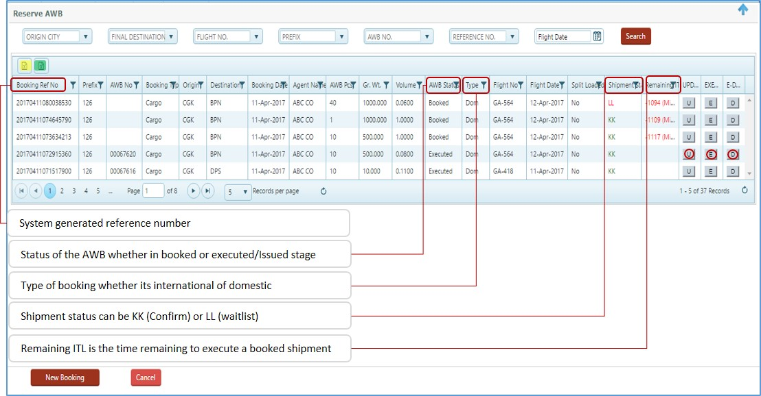

1. The shipments are listed based on the default number of records per page, which is set to 5, this can be changed by the user from the bottom of screen (figure 9)
2. 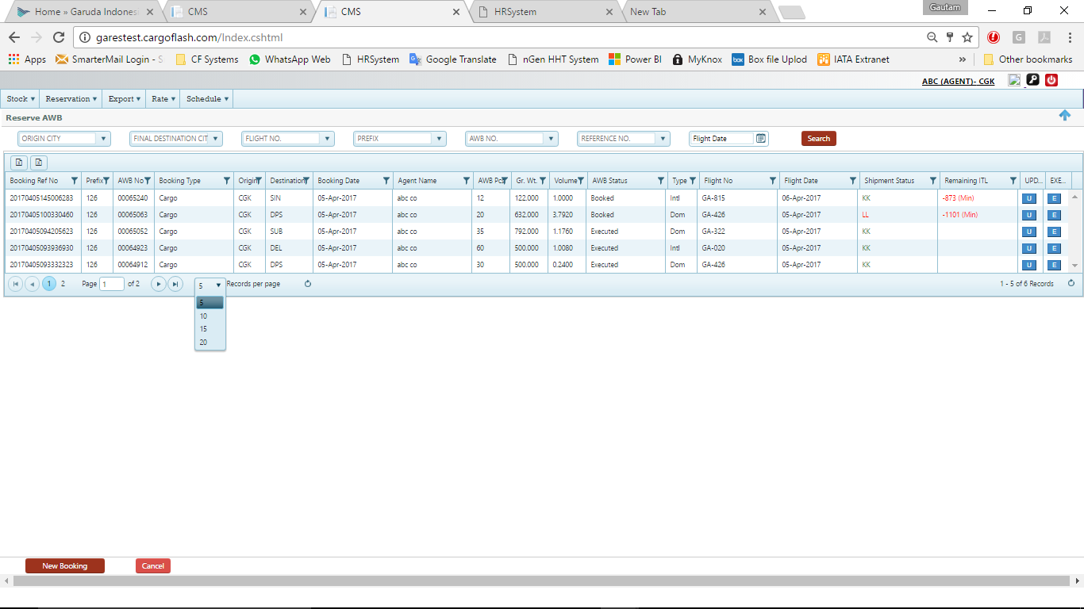The pages can be also navigated here to go to the next/previous/first/last page

Figure 9: Page Navigation

1. 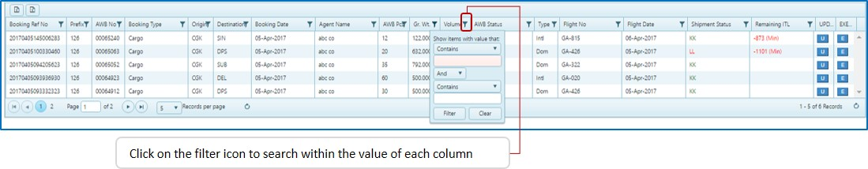Each column has a filter icon which can be used to filter from the column information, various combinations can be used using this tool, for example searching in the AWB No. for an AWB starting with 7 or ending with 6 or containing 756 within it (figure 10)

Figure 10: Column Filters

1. The AWBs in the grid can be downloaded in an Excel format by clicking on the page icons on the left hand top side of the grid, these have been highlighted in yellow and green colour in figure 8, one of these (yellow) is to download the list of AWBs on display on screen the other one (green) is to download all the AWBs for this user.
2. The columns of the Grid are explained one by one below (figure 8)
   1. Booking Reference no. – This is a system generated reference no. against each shipment, for domestic shipments it is very crucial as it is the only identifier in absence of AWB number before shipment is executed/issued
   2. Prefix – The Airline AWB prefix
   3. AWB No. – The AWB number of the shipment, for domestic shipments this is not generated till the time shipment is executed/issued
   4. Booking Type – This can be cargo or courier
   5. Origin - The shipment origin
   6. Destination - The shipment destination
   7. Booking Date – The date when the booking had been in the system
   8. Agent Name – For agent login, it will always be self
   9. AWB Pcs – The total number of pieces in the shipment booking
   10. Gr. Wt. – The actual gross weight of the shipment
   11. Volume – The volume of the shipment in CBM
   12. AWB Status – This shows the lifecycle status of the Air Waybill i.e. Booked, Executed, FOH, RCS, MAN, DEP, ARR, RCF, NFD and DLV
   13. Type - This is to identify between domestic and international shipments
   14. Flight no. – The first flight on which the shipment is booked
   15. Flight Date – The first flight date on which the shipment is booked
   16. Shipment Status – The reservation status of the shipment, it can be KK for confirm or LL for waitlist
   17. Remaining ITL – This is the time remaining to execute/issues a booked shipment, once the ITL has reached ‘0’ it will not allow that shipment to be executed and if any penalty exists for breaching ITL same shall be levied as part of Invoice
   18. UPD or ‘U’ button – This is to update an existing booking, update is not allowed once shipment is executed/Issues
   19. EXE or ‘E’ button – The booked shipments can be executed by entering in the execute mode, however if the ITL is breached then execution of shipment is not allowed.
   20. E-Dox or ‘D’ button – Here the agent/user can add scanned shipment documents as an e-pouch; like invoice, packing list, certificate of origin, etc.

# New Booking –

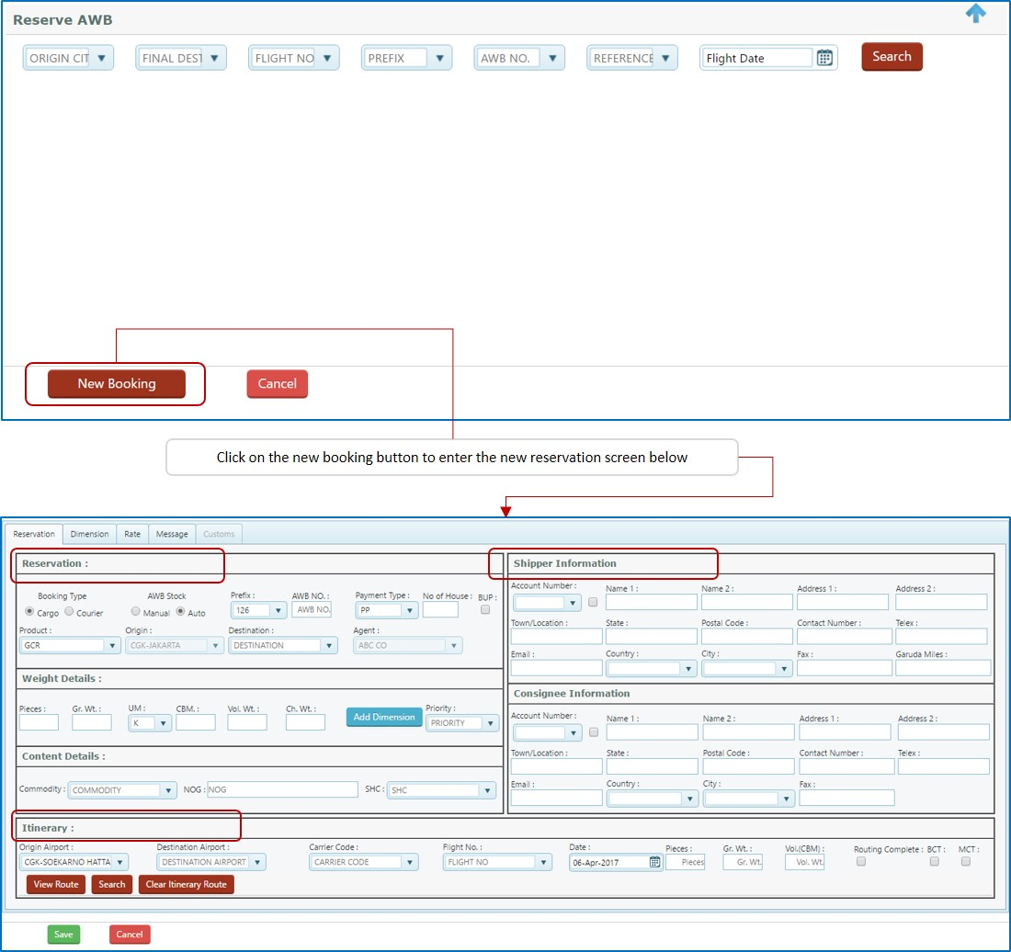After clicking the sub-module ‘Cargo Booking’ from ‘Reservation’ module, from the screen that opens up click on ‘New Booking’ button on lower left hand corner of the screen as shown in the below figure 11

Figure 11: New Booking

The reservation screen has been broadly divided into three sections, namely; Reservation, Shipper/Consignee and Itinerary. These sections are explained in detail further below –

# Reservation – This is the first step for reservation, In this section the primary information for the shipment booking is provided this includes destination, product, weight details, etc. each of this fields with steps have provided below –

1. Booking type - Select ‘Cargo’ (pre-selected) from the radio button choice, ‘courier’ needs to be chosen only if separate AWB series for courier has been issued to the agent
2. AWB Stock – This is to be selected between ‘auto’ and ‘manual’, by default ‘auto’ is selected. Auto means system will be generating and assigning an AWB for the shipment from the system auto AWB pool. However, this is only allowed when the agent has been assigned to be auto stock allowed by the airline. If AWB stock is selected as manual then the user will proceed to the next field, AWB number.
3. Prefix and AWB NO – This is applicable only when AWB stock has been selected as manual, the user needs to select the AWB prefix and then enter the AWB number from the stock that has been issued to the agent by airline, system check and verifies the AWB number whether it had been actually issued to the agent and is unused and not void or blacklisted.
4. Payment Type – This is to be selected between PP (Prepaid) and CC (Collect), by default it is PP
5. No.of House – In case the shipment has any HAWBs, then user must specify the number of HAWBS that will be entered, only if this is updated then the user may update the HAWB information in the FHL module
6. 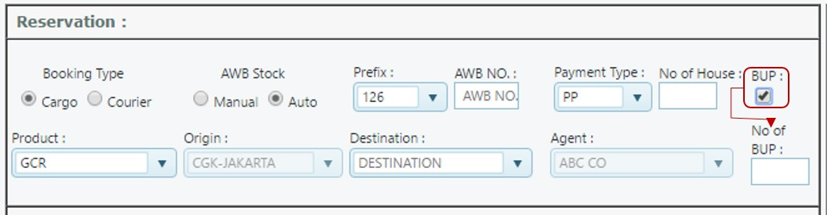BUP - Select this check box if the shipment is being booked under ULD rating and being brought as a shipper build up unit, once this is selected another field is displayed which asks for the number of BUP units (figure 12), the details of BUP are entered from the dimension screen which has been discussed under point ‘k.vii’

Figure 12: BUP entry

1. Product – Select the product from the given list, by default the product is GCR
2. Origin - This is auto filled from the agent login and cannot be changed
3. Destination – Select the final shipment destination
4. Agent - this is auto filled from the user login
5. Weight details – this is a sub-section of reservation section and consists for fields to update weight and dimension details. The sub fields are –
   1. Pieces – Please enter the shipment pieces
   2. Gr. Weight- Enter the gross weight of the shipment
   3. UM – This is to select the weight unit between KG (Kilogram) and LBs (Pounds) by default it is set at KG
   4. CBM – Please enter the volume of shipment in CBM, and it will update the volume in Kgs in the next field
   5. Vol. Wt. – If CBM is entered the volume weight in Kgs is auto updated, in case CBM is not known user can also enter the volume weight and system can reverse calculate the CBM
   6. Ch. Wt. – This is calculated auto based on Gross and volume weight
   7. 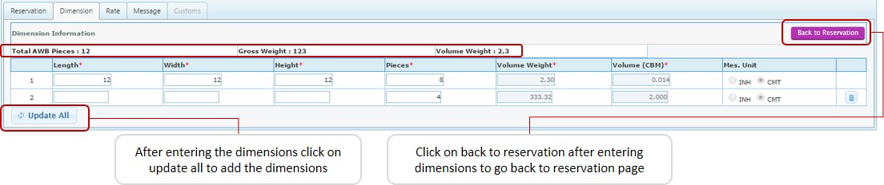Add Dimensions – click on the add dimensions button if dimensions of the pieces are known, this is optional process during booking and can be skipped by providing the volume information from either (iv) or (v) above. In case of BUP shipment the details of the ULDs are also updated from here. The process for adding the dimensions are given below (figure 13) :

Figure 13: Add Dimensions

On the top of the screen the shipment total pieces, gross weight and volume weight if entered are displayed. Dimensions are entered row wise and for each piece a separate row can be added. The volume weight in kgs and volume in CBM is auto calculated and updated in reservation screen. The last column is to select whether dimensions are in CMT (centimetre) or INH (Inches), default selection is set at CMT.

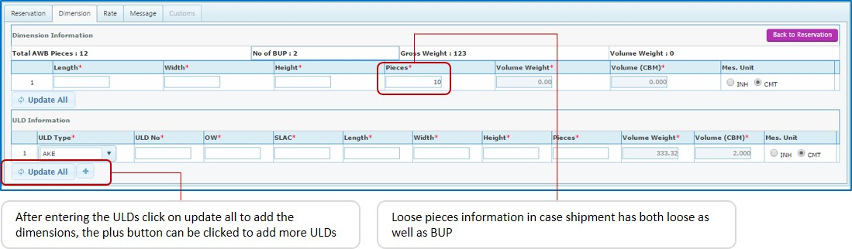In case of BUP shipments on the same dimensions tab additional options are listed to add ULD details (figure 14)

Figure 14: ULD details for BUP

The ULD information consists of the following -

* ULD Type – Select the ULD type, like AKE, PMC, etc.
* ULD No. – Enter the serial number of the ULD
* OW – Enter the owner code of the ULD - GA, QG, etc.
* SLAC – Here the user needs to enter the count of pieces inside the ULD, i.e. SLAC or Shipper Loaded and Counted
* Length, Width and Height – Enter the dimensions of the pieces loaded inside the ULD
* Pieces – Enter the pieces for the dimensions
* Volume weight and Volume CBM - these are for the pieces loaded inside the ULD (auto filled)
* More ULDs can be added by clicking on the plus sign
  1. Priority – Select the priority from the dropdown (disabled for agent login)

1. Content details – This sub-section is used to update the contents of the shipment and comprises of three fields, which are -
   1. Commodity – Select the shipment commodity from the list, user can search by commodity name or commodity item number
   2. NOG – Nature of goods is free text, but a mandatory field
   3. SHC – Select special handling code or SHC in case of shipment being non-general like VAL, HUM, RFL, etc. user can add multiple SHCs to a shipment

# Shipper/Consignee information – This section is used to enter the shipper/consignee information, during booking this is optional and user may wish to skip this, however, at the time of execution filling the shipper consignee information is mandatory –

Figure 15: Shipper/Consignee information

User can use the existing system database for entering the shipper and consignee information, to do this from the account number drop down select the account number or the shipper name; all the fields as saved in the database will be updated.

In case a shipper or consignee does not exist in the system database then user can manually enter the details manually, in case user wants to save such new data entry in the system database then he/she can select the checkbox against the ‘Account Number’ dropbox. This is shown with a red arrow in the figure 15.

# Itinerary – This is the section where user selects the route and flights on which shipment needs to be sent. The steps to select and/or create a route is explained broadly in the figure 16 below and thereafter the steps are explained one by one in detail.

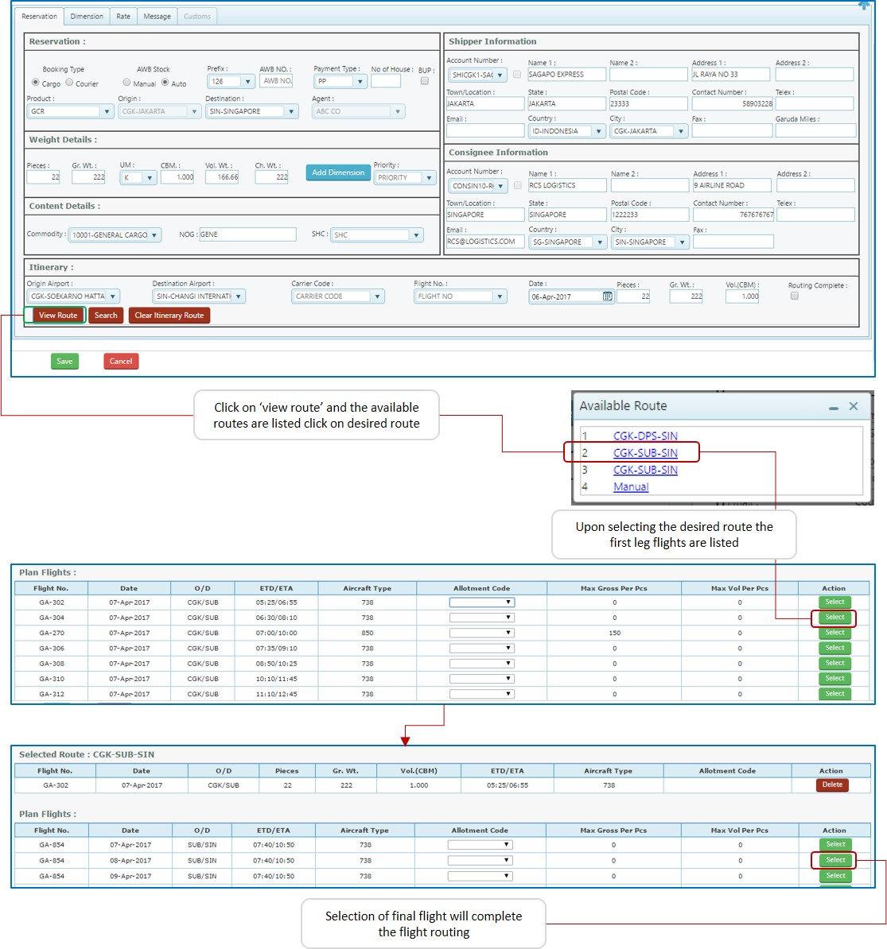

Figure 16: Flight Itinerary

The origin and destination are picked by automatically in the itinerary, along with the flight date as the current date. Pieces, gross weight and volume (these are used to create split booking and is explained later in the document) are also updated from the earlier updated sections.

The carrier code and flight number are only required to be entered in case of Interline airline booking and is beyond the scope of this manual.

The steps to select flight itinerary are as below (refer figure 16) –

* + - * 1. Click on ‘View Route’ button
        2. This is open the available flight routes in a pop-up screen
        3. Select the desired flight route
        4. In case no flight route is available or want some other route than given by system, click on the ‘manual’, will explain this process later.
        5. 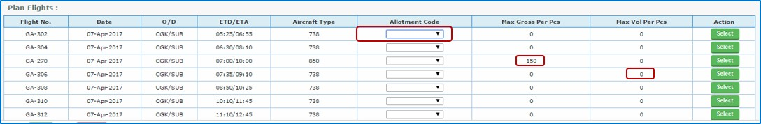Selecting the desired flight route, will list the available flights for first sector. In case the agent has been allocated or given special space allotment then user can select from the dropdown list for allotment code, user will be able to view and select only the allotment codes that have been assigned to that agent.

Figure 17: Select Flight

The grid lists the maximum gross weight per piece and also maximum volume per piece if the same has been set by airline, in case such value is displayed as zero, this means no maximum limit has been set for this flight. User has to click on select the select a desired flight

* + - * 1. 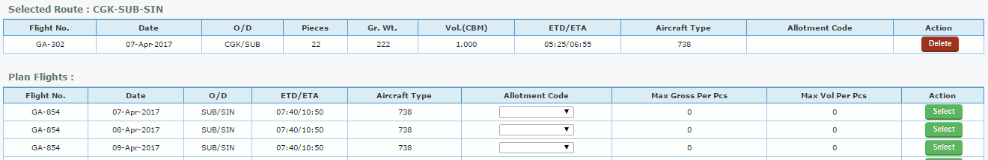In case of transit flight, the next sector flight will be listed post selection of the first segment and first segment is listed on top. In case user wants to remove this segment and user can click on delete button

Figure 18: Second sector

* + - * 1. Once all the flights are selected till final destination, system completes the route and will allow the user to save this booking. To save the booking click on the ‘Save’ button.
        2. For manual selection of routing,

If the origin-destination has a direct flight, then just click on ‘search’ button and select the desired flight, as per steps given above

If there is no direct flight, then In the destination airport enter the transit point

click on ‘search’ button and select the desired flight, as per steps given above

Now the origin airport is auto filled with the destination airport of the first selected flight

In the destination airport enter the flight destination and click on ‘search’

Select the flight.

Repeat steps ‘iv’ to ‘vi’ till final destination is updated and route is completed

System will not allow incomplete routed shipment to be saved.

In case user wants to terminate shipment at a particular transit point and not book till the final destination, then user needs to select the checkbox named ‘routing complete’, this will allow the user to save an incomplete routed shipment.

Figure 19: Force routing complete

# Update Booking –

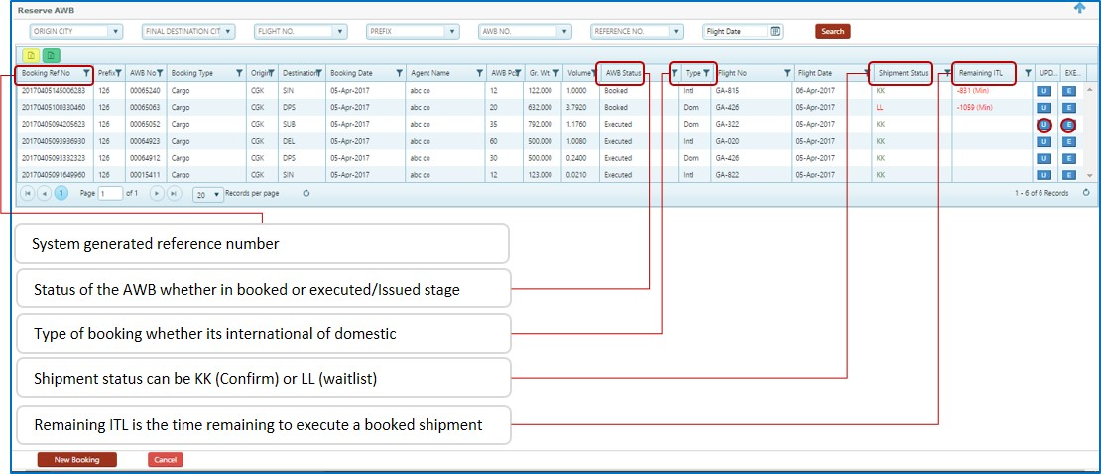Once the booking is saved, it is listed on the AWB reservation grid. System generates the reference number only in case of domestic booking and in case of International shipment booking both the reference number and if auto stock the AWB number as well.

Figure 20: Reservation Grid

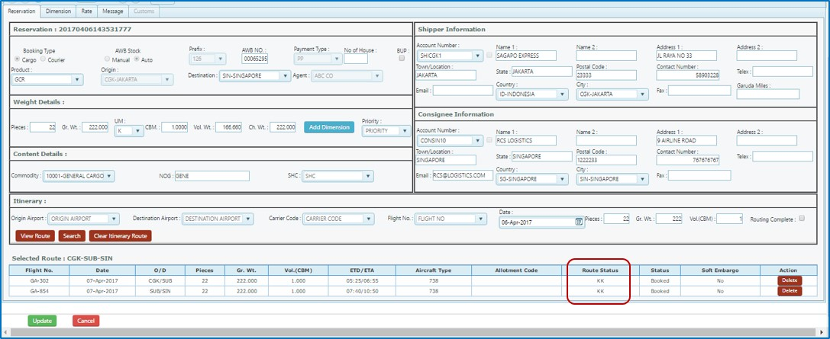Keeping in mind the remaining ITL or the issue time limit, user can click on the ‘U’ tab to enter the update mode of the booking screen (once ITL is breached system does not allow any changes) , this will open the below screen (figure 21).

Figure 21: Update booking

Update booking allows user to change all the reservation details including flight itinerary. It also displays the route wise status, whether KK or LL.

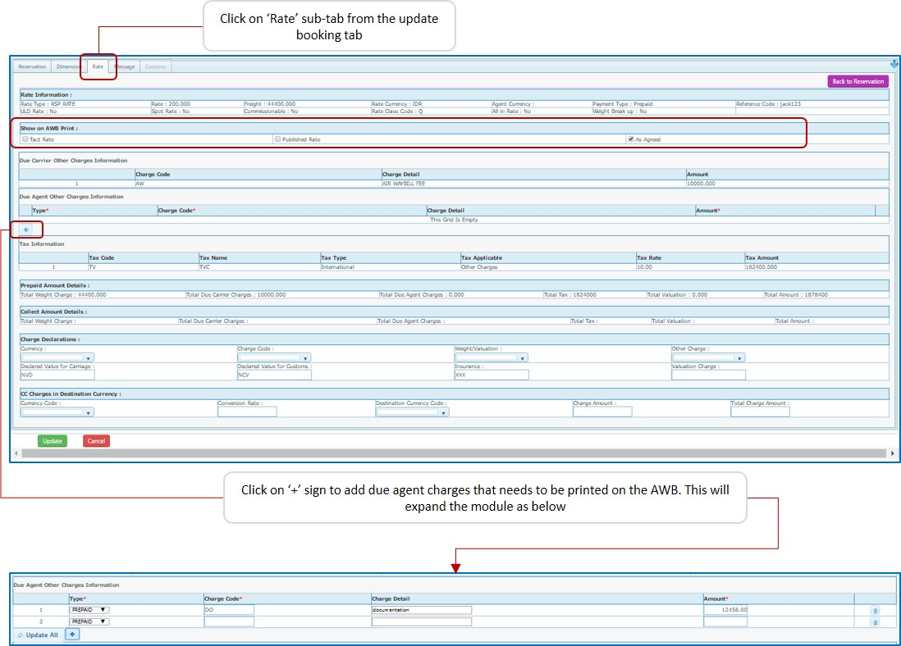From the update booking screen user can view the applied rate for the shipment and also add the due agent charges that will be printed on the AWB (figure 22). To enter into the rate tab follow these steps:

Figure 22: AWB Rate

1. Click on the ‘Rate’ sub-tab from the update booking tab
2. The rate sub-tab is divided into different sections :
   1. Rate Information – This section gives information on the rate type that has been applied on this shipment, whether ULD rate is applied, the applied rate and total freight. If spot or commission is applicable, currency and reference code of applied rate.
   2. Show on AWB price – User needs to select here regarding what rate to be printed on the AWB, the choice is between TACT rate, published rate, or printing ‘As Agreed’
   3. Due Carrier and other charges information - The other due carrier charges that have been applied on the AWB are listed here
   4. Due Agent and other charges information – User can add the due agent charges that are applicable on the shipment and wants to print on AWB. To add due agent charges click on the (+) sign in the section (refer figure 22), this will expand the page to allow adding of charges. User can select whether charges are prepaid or collect, add charge code, charge description and amount. User can add multiple lines by clicking on the (+) button.
   5. Tax Information - Next Section is the tax information, this gives all the taxes that have been levied on this AWB
   6. Prepaid Amount Details – This details the total prepaid amount (revenue) for the AWB
   7. Collect Amount Details – If the shipment is collect than all the collect charges will be listed here
   8. Charge Declaration – This section maybe used by the agent to update any custom related charge information, like declared value for carriage.
   9. CC Charges in destination currency – In case of charges are to be collected in destination currency for Charges Collect shipment, the same can be updated manually by the user here
3. Click on ‘update’ button to save the rate information

# Execute Booking –

Execute a booking means the shipment has been committed by the agent, in case of top-up agents this is when the money will be deducted from the agent’s account. A shipment can be executed only if within the ITL or Issue time limit, beyond this it is considered as a no-show shipment.

To execute a shipment, from the reservation grid click on ‘E’ tab, the screen similar to update booking is opened. Only KK of confirm status shipments can be executed!

User needs to update missing information, if any, which were optional during booking, i.e. the shipment dimensions and shipper/consignee information. These are mandatory for shipment execution.

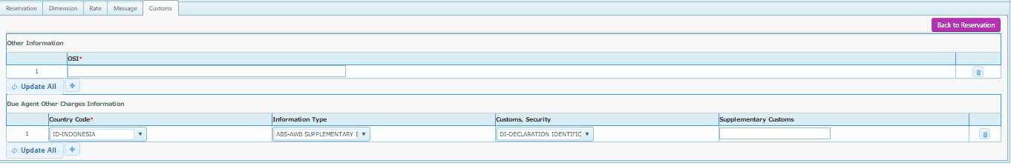During execution an additional sub-tab is activated, i.e the ‘Customs’ tab, this is an optional information tab and if user wants then can update it or else just leave it.

The information other shipment information (OSI) and other customs information (OCI)

Once all these information is entered click on ‘Execute’ button, this will execute the shipment.

On the reservation grid the status of the shipment will be changed to ‘Executed’ and at this stage for domestic shipments system assigns an AWB number.

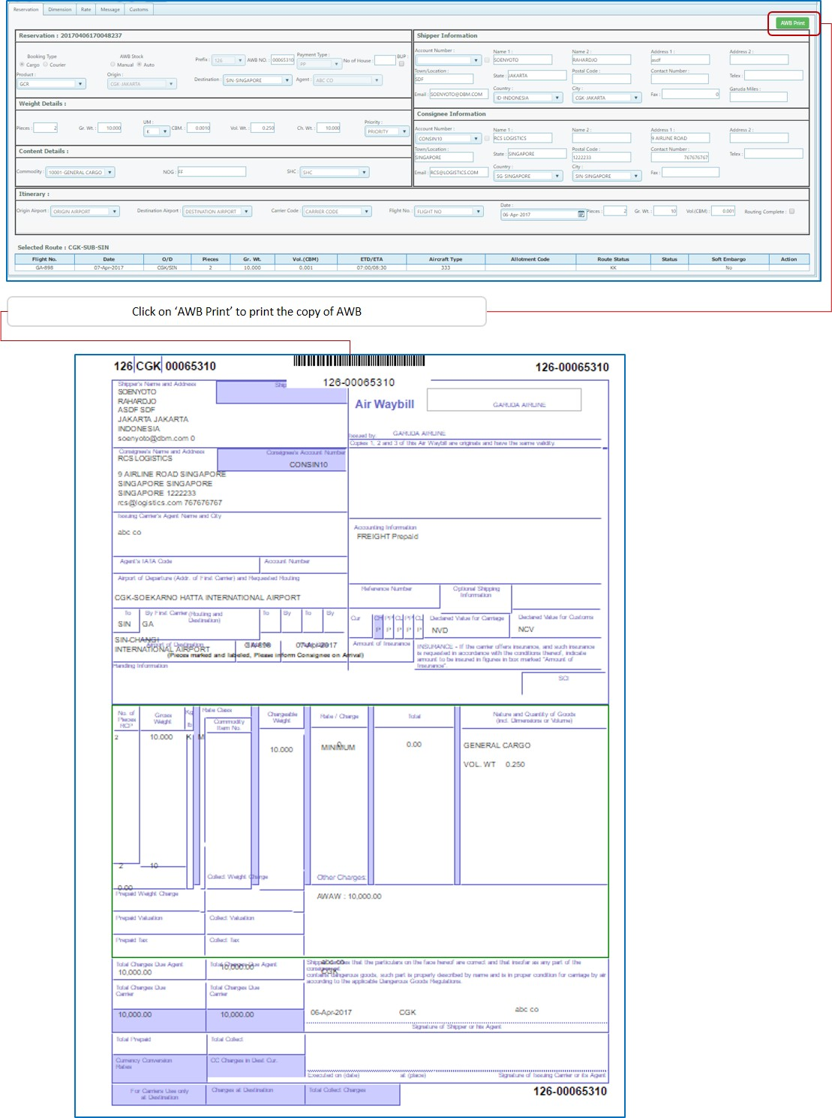From the same grid click once more on the ‘E’ (execute) tab, now on the screen that opens, on the right hand top side a green button is displayed with ‘AWB Print’, click on this button to take a printout of the AWB.

Figure 23: AWB print

# E-Dox or E-Pouch –

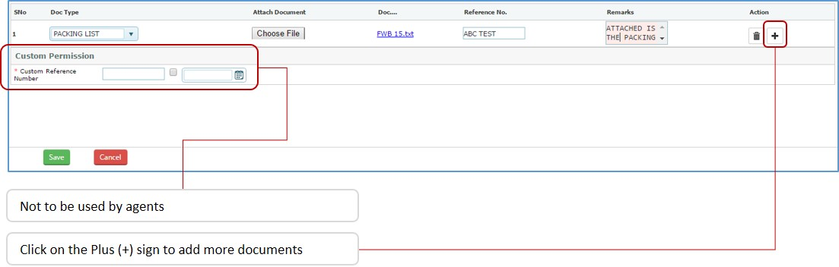E-Dos can used as an electronic pouch by agent for attaching scanned shipment documents like, invoice, packing list, Shipper letter of DG declaration etc.

The steps to use E-Dox is as below -

1. User needs to click on the ‘D’ button from the Reservation Grid for the desired AWB
2. Select the document type from the drop down list
3. Click on choose file button choose the desired file from user’s computer
4. The selected file is listed
5. Use the reference no. field to enter reference number of the document attached, if any
6. Remarks can be added in the remarks column
7. Click on plus (+) to add more documents if required
8. The delete button can be used to delete any added document
9. Once done, click on save button to save the record with AWB.

# **HAWB Capture**

# This is the Consolidation List or FHL CIMP message sent by the agents giving details on the House Waybill under a particular Air Waybill for a shipments that are booked on a particular flight on a date. This gives the system the details of House Airway Bill (HAWB) which are brought by the agents and do an acceptance of shipments under HAWB. In case the FHL message has not been received then user also has the option of manually adding the HAWBs here.

To access the ‘HAWB Capture ’ screen in the system, please go to the ‘Reservation’ module for the top menu and from the available list click on ‘HAWB capture’ (figure 24 below), this will open the HAWB main search screen which is further shown under figure 24. Only those AWBs are listed in the HAWB screen for which at the time of booking/execution, agent has provided that this shipment has HAWB and the number of AWBs, this shipment will have.

# Adding new HAWB –

The process of adding a new HAWB from the FHL screen is only possible when at the time of booking or execution the user has specified that the shipment has HAWB and the number of HAWBs it has. In case during booking or execution stage user has updated 3 HAWB then only 3 house AWBs can be added from FHL screen, also the number of HAWB is limited with the number of pieces in the shipment, i.e., a shipment with 10 pieces cannot have more than 10 HAWBs.

To access the FHL details and add a new HAWB, click on the **blue button** with ‘FHL’ written on it, refer figure 24 below; the FHL with a **green button** means that FHL entry has been completed for this AWB. Clicking this would open the below screen (figure 24.)–

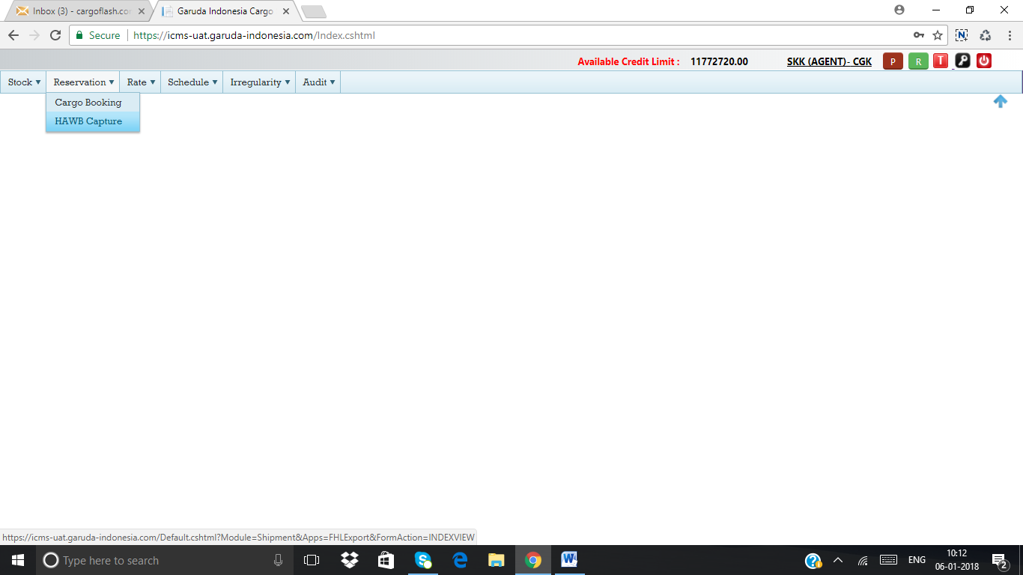

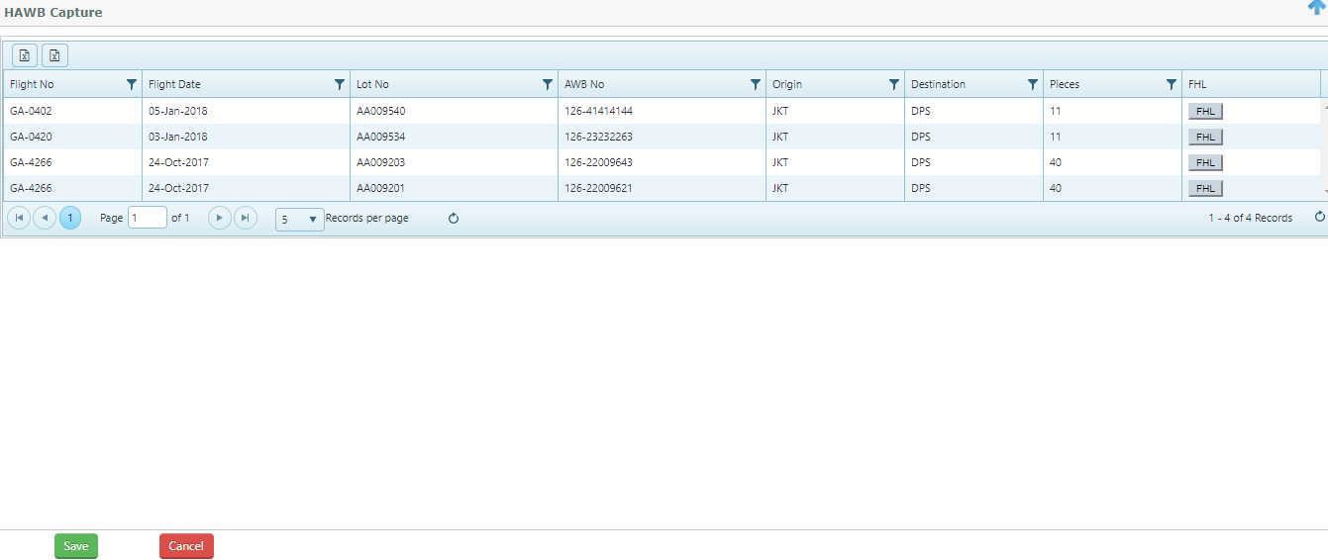

Figure 24: Adding HAWB

# On the above screen (figure 24) the details of the Maser Air waybill is listed including Lot number (in case shipments are received in part) & AWB number, number of pieces in the total shipment, number of HAWB under this AWB, etc. In order to add HAWB user must click on the ‘Add’ button (figure 25), this open the below screen as shown in figure 25

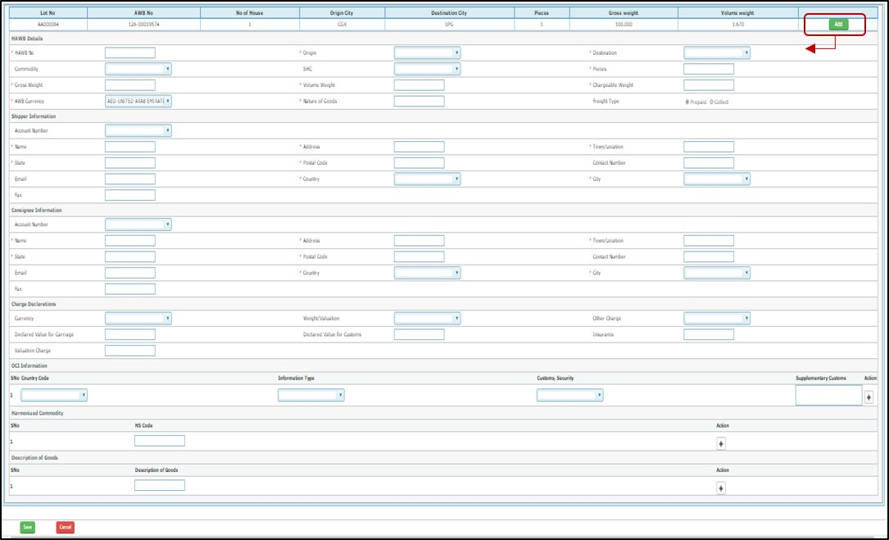

Figure 25: HAWB Details

Once user clicks on ‘Add’ the HAWB screen is opened, this ‘Add’ button is activated for each HAWB in the shipment. User has to manually fill in all the information, the mandatory fields are marked with an asterisk (\*) and unless filled will not be allowed to save. Once users updates data and clicks on ‘**Save**’ the HAWB gets added to the MAWB.

The HAWB is divide in three sections:

* + - 1. HAWB Details – In this section the details of the HAWB are entered and the fields to be filled in are
         1. HAWB No : This is free text
         2. Origin : This is the origin of the HAWB and can be different from MAWB
         3. Destination: The HAWB destination, can be different from MAWB
         4. Commodity: The HAWB commodity, can be different from MAWB
         5. SHC: The HAWB commodity, can be different from MAWB
         6. Pieces: This cannot equal to or more than the MAWB pieces
         7. Gross Weight: This cannot be equal to or more than the MAWB gross weight
         8. Chargeable weight: This cannot be equal to or more than the MAWB chargeable weight
         9. AWB Currency: This is the currency on which HAWB is executed
         10. Nature of goods: This is free text
         11. Freight type: Is either prepaid or Collect
      2. Shipper Information – The shipper information can be manually entered or from the ‘Account number’ dropdown selected from the system database
      3. Consignee Information - The consignee information can be manually entered or from the ‘Account number’ dropdown selected from the system database
      4. Charge Declaration – The fields here are
         1. Currency
         2. Weight/Valuation - this the total weight and valuation charge on the AWB description, whether prepaid or collect
         3. Other Charges – the other charges due agent description, whether prepaid or collect
         4. Declared value of carriage
         5. Declared value for customs
         6. Insurance
         7. Valuation charge
      5. OCI Information – This is the Other Customs information which the agent can fill in, if required
      6. Harmonised Commodity – The harmonised commodity or HS code of the commodity for customs purpose, can be added multiple times by clicking on the plus (+) sign
      7. Description of Goods - The description of the commodity for customs purpose, can be added multiple times by clicking on the plus (+) sign

# **Rate**

The rate module of the system allows the agents to search for the published rates, promo rate of its own RSP rate.

To access the rate screen in the system, please go to the ‘Rate’ module from the top menu this will list down two options, ‘Spot Rate Request’ and ‘Search Rate’.

**4.1 Applying a Spot Rate**

Figure 26: Spot Rate Grid

Once the spot rate is approved by the airline, Agent/Forwarder user can apply the spot rate from the reservation screen under apply spot rate Tab

To apply this spot rate code:

* + 1. First go to Reservations screen (refer module 2.2 for detailed process on how to do this ),
    2. Then for the AWB against which spot rate is to be applied click on ‘E’ tab to enter the execute tab (refer 2.4 for detailed process on how to do this)
    3. From the AWB screen that opens click on the rate tab, as shown below in figure 34
    4. In this tab on the right hand corner there will be green button named ‘Apply Spot Code’, click on it and this will open a pop-up window to apply the spot code, this is depicted in the figure 34 for better understanding
    5. This pop-up displays the shipment information along with current applied rate
    6. Under section code information in the pop-up, select ‘spot code’
    7. Selecting this will enable a drop-down menu from which available spot codes can be selected, select the one that is applicable
    8. Click on ‘Applied code’ button
    9. This will apply the spot rate to the shipment

The above process has been depicted in the below figure for clearer understanding

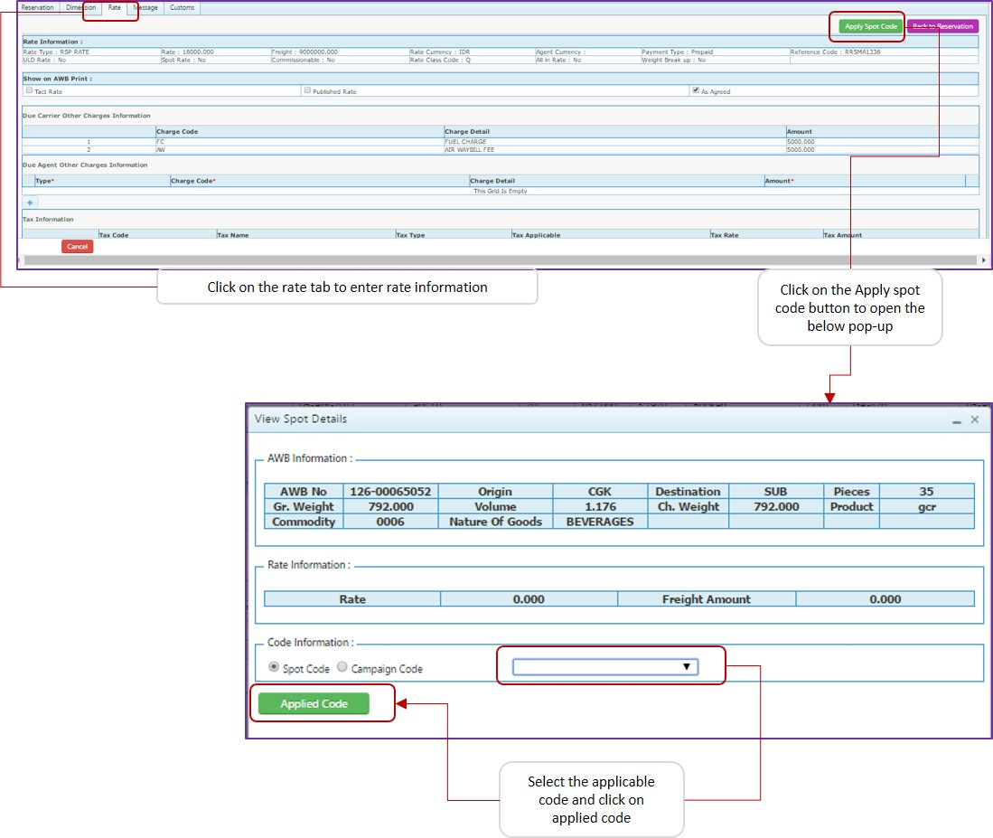

Figure 27: Apply Spot Rate

# 4.2 Search Rate

Using the ‘search rate’ sub-modules’ agents can check the Airline Published rates, promo rates if any and even their own agent specific rates. To access the search rate sub-module, from the ‘Rate’ top menu sub-options click on ‘Search Rate’, this will open the following screen:

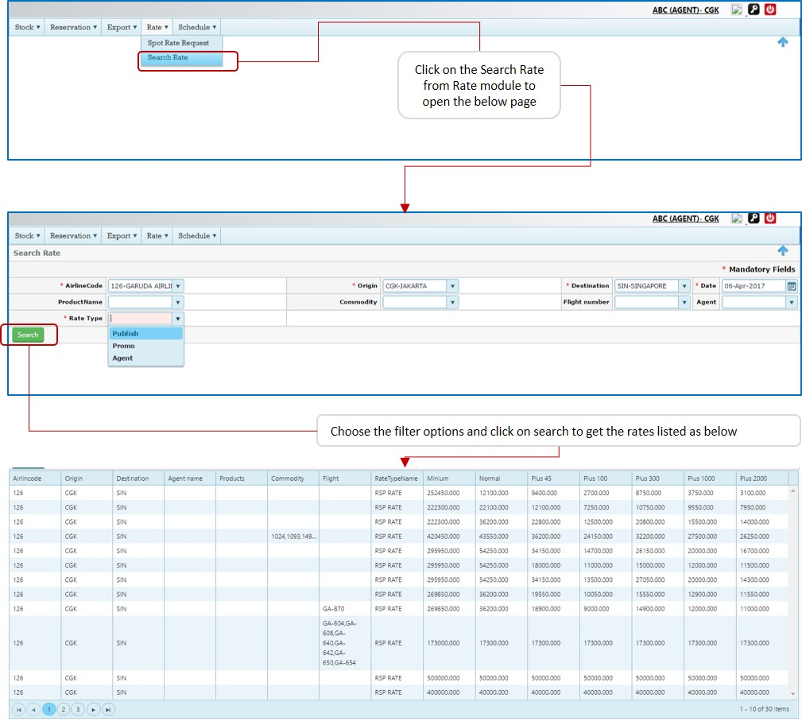

Figure 28: Search Rate

The steps to search rates have been given below:

* + - * 1. Enter the required search options from the given filter options, these are –

Airline Code – Select the Airline for which rate is being looked for, this is mandatory

Origin – The shipment origin, this is mandatory

Destination – The shipment destination, this is mandatory

Date – The date for which rate should be applicable, this is mandatory

Product Name – Select the product for which rate is searched, eg. Airport to Airport, Express, etc. (optional)

Commodity – If user want to search rate for a specific commodity (SCR), this is optional

Flight Number – Select the flight number is searching a flight based rate (optional)

Agent - This is deactivated for agent login

Rate type – This is mandatory selection and has to be chosen between, published, Promo and Agent rate

* + - * 1. Click on the ‘Search button’
        2. This will open the rate list as per figure 35 above

# **Schedule**

Through this module user can search for the flight routing option between an origin and destination, system will list the available flights. To enter this module in the system, please go to the ‘Schedule’ module from the top menu; this will list down the sub-module ‘search schedule’. The screens are discussed as below -

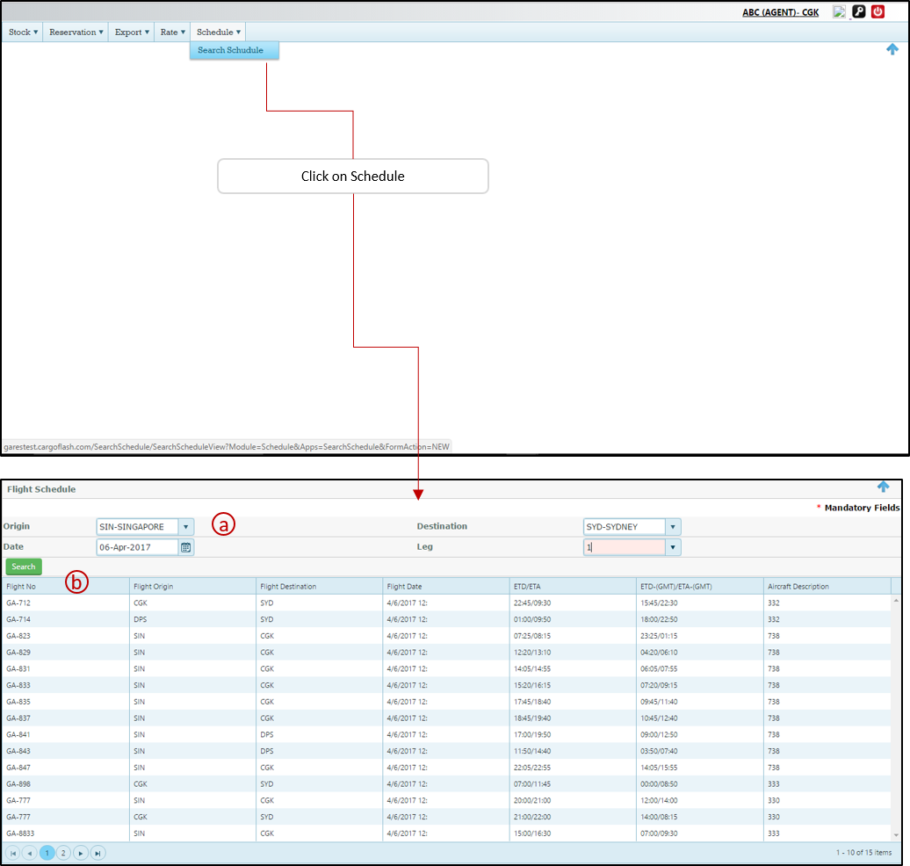

Figure 29: Search Flight Schedule

Upon clicking the search schedule the screen to input search fields is displayed, user can select the desired origin and destination, the date on which user wants the flight schedule to be displayed for and finally the leg, the leg means the transit points for this route, ‘0’ will mean user is searching for a direct flight.

Once user clicks on search the various flight options are listed, transit points are created automatically based on the legs selected. The details given include, departure and arrival times in both local as well as UTC and the Aircraft type operated on the segment.

[Figure 1: System Login Window 4](C:\\Users\\Pradip\\Desktop\\Handbook - Agent Portal.docx" \l "_Toc502998717)

[Figure 2: Home Page 5](file:///C:\Users\Pradip\Desktop\Handbook%20-%20Agent%20Portal.docx#_Toc502998718)

[Figure 3: Module - Stock Management 7](file:///C:\Users\Pradip\Desktop\Handbook%20-%20Agent%20Portal.docx#_Toc502998719)

[Figure 4: Accessing AWB Stock Report 8](#_Toc502998720)

[Figure 5: Stock report view 10](file:///C:\Users\Pradip\Desktop\Handbook%20-%20Agent%20Portal.docx#_Toc502998721)

[Figure 6; Stock History 12](#_Toc502998722)

[Figure 7: Reservations 13](file:///C:\Users\Pradip\Desktop\Handbook%20-%20Agent%20Portal.docx#_Toc502998723)

[Figure 8: Reservation Grid 15](file:///C:\Users\Pradip\Desktop\Handbook%20-%20Agent%20Portal.docx#_Toc502998724)

[Figure 8: Reservation Grid 15](file:///C:\Users\Pradip\Desktop\Handbook%20-%20Agent%20Portal.docx#_Toc502998725)

[Figure 9: Page Navigation 15](file:///C:\Users\Pradip\Desktop\Handbook%20-%20Agent%20Portal.docx#_Toc502998726)

[Figure 10: Column Filters 16](file:///C:\Users\Pradip\Desktop\Handbook%20-%20Agent%20Portal.docx#_Toc502998727)

[Figure 11: New Booking 18](file:///C:\Users\Pradip\Desktop\Handbook%20-%20Agent%20Portal.docx#_Toc502998728)

[Figure 12: BUP entry 19](file:///C:\Users\Pradip\Desktop\Handbook%20-%20Agent%20Portal.docx#_Toc502998729)

[Figure 13: Add Dimensions 20](file:///C:\Users\Pradip\Desktop\Handbook%20-%20Agent%20Portal.docx#_Toc502998730)

[Figure 14: ULD details for BUP 20](file:///C:\Users\Pradip\Desktop\Handbook%20-%20Agent%20Portal.docx#_Toc502998731)

[Figure 15: Shipper/Consignee information 22](file:///C:\Users\Pradip\Desktop\Handbook%20-%20Agent%20Portal.docx#_Toc502998732)

[Figure 16: Flight Itinerary 23](#_Toc502998733)

[Figure 17: Select Flight 24](file:///C:\Users\Pradip\Desktop\Handbook%20-%20Agent%20Portal.docx#_Toc502998734)

[Figure 18: Second sector 24](file:///C:\Users\Pradip\Desktop\Handbook%20-%20Agent%20Portal.docx#_Toc502998735)

[Figure 19: Force routing complete 25](file:///C:\Users\Pradip\Desktop\Handbook%20-%20Agent%20Portal.docx#_Toc502998736)

[Figure 20: Reservation Grid 25](file:///C:\Users\Pradip\Desktop\Handbook%20-%20Agent%20Portal.docx#_Toc502998737)

[Figure 21: Update booking 26](file:///C:\Users\Pradip\Desktop\Handbook%20-%20Agent%20Portal.docx#_Toc502998738)

[Figure 22: AWB Rate 27](file:///C:\Users\Pradip\Desktop\Handbook%20-%20Agent%20Portal.docx#_Toc502998739)

[Figure 23: AWB print 29](file:///C:\Users\Pradip\Desktop\Handbook%20-%20Agent%20Portal.docx#_Toc502998740)

[Figure 24: Adding HAWB 32](file:///C:\Users\Pradip\Desktop\Handbook%20-%20Agent%20Portal.docx#_Toc502998741)

[Figure 25: HAWB Details 33](#_Toc502998742)

[Figure 26: Spot Rate Grid 35](file:///C:\Users\Pradip\Desktop\Handbook%20-%20Agent%20Portal.docx#_Toc502998743)

[Figure 27: Apply Spot Rate 36](file:///C:\Users\Pradip\Desktop\Handbook%20-%20Agent%20Portal.docx#_Toc502998744)

[Figure 28: Search Rate 38](file:///C:\Users\Pradip\Desktop\Handbook%20-%20Agent%20Portal.docx#_Toc502998745)

[Figure 29: Search Flight Schedule 40](#_Toc502998746)

**Notes:**

--------------------------------------------------------------------------------------------------------------------------------------------------------------------------------------------------------------------------------------------------------------------------------------------------------------------------------------------------------------------------------------------------------------------------------------------------------------------------------------------------------------------------------------------------------------------------------------------------------------------------------------------------------------------------------------------------------------------------------------------------------------------------------------------------------------------------------------------------------------------------------------------------------------------------------------------------------------------------------------------------------------------------------------------------------------------------------------------------------------------------------------------------------------------------------------------------------------------------------------------------------------------------------------------------------------------------------------------------------------------------------------------------------------------------------------------------------------------------------------------------------------------------------------------------------------------------------------------------------------------------------------------------------------------------------------------------------------------------------------------------------------

**END**

**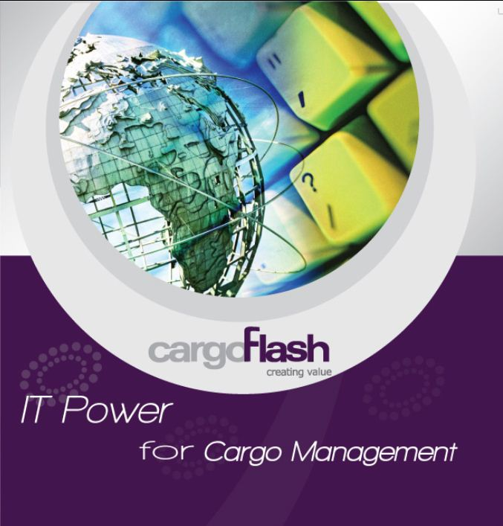**

142, Udyog Vihar, Phase-IV, Haryana. 122001. India. **Tel :** +91-124-7125036, 7125081 **Fax :** +91-124-7125044 **Email** : [info@cargoflash.com](mailto:info@cargoflash.com) **Web** : <http://www.cargoflash.com/>